38.1

Complete the crossword with the correct form of words from A and B opposite.

1 2 3

4 5 6

7

8 9

10

11

12

13

14 15

16 17

Across
1 A group of shops with the same name (5)
5 Shopping by post (4,5)
8 A shop where you might buy something you’ve forgotten to buy elsewhere is a store (11)
11 A large shop with many different products (10,5)
12 Where you pay in a supermarket (4)
13 Large shops have many different (8)
14 With mail order, you can order
(2,4)
15 Here you can find a lot of different shops, out of town (4)
16 A shop is a type of convenience store in the UK (6)
17 Another word for where you pay in a supermarket (8)
Down
2 When you buy things online (8,8)
3 The different levels of a department store (6)
4 With mail order, you can do your shopping on (3, 5)
6 Selling without shops (6,5)
7 Buying and selling on the Internet
(1-8)
9 With mail order, you a catalogue (6,4)
10 Where you buy food, clothes and some other products (11)
12 British English for ‘cart’ (7)
13 A seller’s ‘place’ on the Internet (4)

38.2

Complete the sentences with words from A and B opposite.
1 In a supermarket, you pay the checkout.
2 More and more books are sold (2 words) the Internet.
3 When you buy clothes mail order, you choose a catalogue.
4 You can order post or (2 words) the phone.

Think about a national or international company which manufactures products. Where are its products sold?

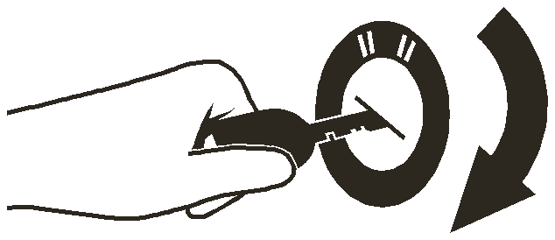39 Product instructions

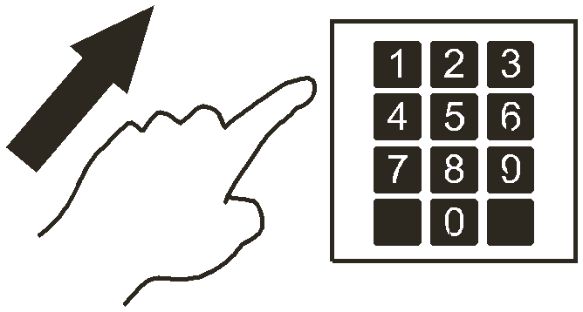A Follow the instructions

1 Pull the lever. | 5 Turn the key to start.
2 Key in your PIN number. | 6 Plug the cable into the socket.
3 Put your ticket into the slot. | 7 Insert your card.
4 Push the door. | 8 Select a language.  Japanese English French

B Press the button
Note
To play a CD:
These instructions use the imperative form of the verb. The imperative is the same as the infinitive form.

1 To switch on, press the ‘On’ button.  ON | 4 Then press the ‘Play’ button.  PLAY
2 Put the CD into the tray. | 5 When you have finished, press the ‘Stop’  button.  STOP
3 Press the ‘Close’ button.  CLOSE | 6 Press the ‘Eject’ button and take the CD out of the tray.  EJECT

39.1

39.2

Match the instructions in A opposite with these products and machines.

a ticket barrier c cash machine (3 instructions) e office door

b orange squeezer d car f PC
Look at B opposite. Put these instructions for recording a DVD into the correct order.

a When you have finished, press the ‘Stop’
e Press the ‘Record’ button.
button.

STOP
RECORD
b Put a blank DVD into the tray. f Press the ‘On’ button.
ON
c Select the TV station that you want to
g Press the ‘Open’ button.
record.
d Push the tray to close it.

Channel 1

Channel 2
OPEN

40 Problems with products 1
Faults
Antonia is having problems with her DVD player. She phones the call centre of the chain store where she bought it.
Assistant: Service department. How can I help?
Antonia: I have a problem with my DVD player. It stopped working last week.
Assistant: What make and model number is it?
Antonia: It’s a Ruby DVD 7000.
Assistant: What exactly is the fault /fɒlt/ –
what’s the technical problem?
Antonia: When I press the button, the tray doesn’t open.
Assistant: How old is the DVD player?
Antonia: I bought it six months ago.
Assistant: OK, Ruby guarantee their products for two years. You can send it back by post for repair. Antonia: That’s difficult. I don’t have the box.
Assistant: Don’t worry. You can take it back to the shop. Where did you buy it?
Guarantees Guarantee /ˌgærənˈtiː/ is a noun and a verb. Note its spelling, not ‘garantee’.
The company repaired the DVD player and returned it to Antonia, but it has stopped working again. She phones the centre again.
Assistant: Service department. How can I help?
Antonia: My DVD player broke down last month. You repaired it, but it stopped working again yesterday.
Assistant: What’s the fault now?
Antonia: I can play DVDs, but I can’t record.
Assistant: Is it still under guarantee?
Antonia: Yes, I only bought it last year.
Assistant: OK. Because it’s happened again, we’ll give you a brand new one as a replacement.
Antonia: That’s great!

40.1Look at A and B opposite. Match the two parts of these sentences.
1 This product is brand
2 This car is still under
3 If you have a problem
4 My CD player stopped
5 When my new computer stopped working, I sent it
a with your new kitchen equipment, just give us a call.
b working two days after I bought it.
c new. I bought it yesterday.
d back to the shop.
e guarantee. It’s less than three years old.

40.2
Match the words in the box to make word combinations from A and B opposite. Look at the example before you begin.

back brand call
centre department guarantee
model new number
send service stop
under working

40.3
Complete the sentences with expressions from the box.

stops working call centre
fault guarantee
repair replacement
take it back under guarantee
Guarantee

1 We our products for two years.

2 If the product doesn’t work, to the shop where you bought it.

3 If the shop can’t help you, phone our .
4 If there is still a , send the product back to us. We will it.
5 If the product again while it is still , send it back to us and we will send you a
.

Talk about a problem you had with a product. Did you a) send the product back for repair, or b) get a replacement product? What happened exactly?

?

41 41Problems with products 2 A.What can go wrong?
You want to purchase – buy – office supplies – products for your office – from a supplier. You do this by sending a purchase order – a document with details of the order – to the supplier. These things can go wrong:
The company loses the order. Purchase is more formal and less frequent than buy
The company supplies the goods. It ships the goods, but they are delivered – sent – to the wrong place.
The goods are delivered to the right place, but they are delivered late.
The wrong goods are delivered. They are not the ones that you ordered.
On delivery, you see that some of the goods are damaged – harmed or broken. Perhaps this happened when they were shipped.
Other products do not work properly – correctly – because they are faulty – they have
faults.
The supplier’s invoice – a document giving information about the goods that you have purchased – is wrong. There are mistakes in the invoice details – the quantities and/or prices are wrong. Perhaps the suppliers want to charge too much – they say the price is more than it really is. If this happens, they should refund – pay back – the difference.
B Keeping customers happy
You work at the supplier’s. In order to keep customers happy in different situations, you could:
apologize – say that you’re sorry. apologize (verb) apology (noun)
give/offer a reduction or discount – lower price – for the next order. The price will be
reduced or discounted.
send a truck to pick up the goods and deliver them to the right place.
take back the wrong products and send the correct products.
give or offer a reduction or discount for this order.
replace the faulty products.
repair the faulty products.
Note
send another invoice.

1 Recently, when buying some goods for my company, I looked on the Internet to find the lowest prices.
2 We found the products were harmed when they were delivered, so I asked the supplier to send others.
3 As we asked for large quantities, we expected to get a lower price (2 expressions).
4 The goods were sent (2 expressions) to our head office, not to the factory where we needed them.
5 The document that the suppliers sent us when they asked us to pay was wrong, so we didn’t pay.
6 The company that we ordered the supplies from has gone out of business.
-------
1 If we lost the order, we would apologize and ask the customer to send it again.
2 If we shipped the goods to the wrong place, we would
3 If the goods were delivered late, we would
(2 expressions)
4 If we delivered the wrong goods, we would
5 If we delivered faulty goods, we would
6 If we sent an invoice with mistakes in it, we would

Noun |  | Verb
apology
damage
 |  | deliver
 |  | discount
 |  | invoice
 |  | order
purchase
 | reduce
refund
replacement
shipping
 | supply

Learner training D: Using dictionaries
A What dictionaries do I need?
You should use two dictionaries: a good bilingual dictionary – in English and your own language
– and a good English–English dictionary, like the Cambridge Learner’s Dictionary.
A bilingual dictionary can be easier to understand, but an English–English dictionary can give you more information about a word or phrase. It’s good to work in English as much as possible.
You can use the CD-ROM versions of these dictionaries, or look up – find – words on the Internet.
And, of course, there are more and more small electronic handheld dictionaries and dictionary applications for devices such as the iPhone.

B What information does a dictionary give?
Each entry gives you a lot of different information. Pronunciation symbols show the pronunciation – the way that you say a word.
Grammar labels show that the word is a noun, verb, adjective, adverb, etc. Sometimes a word can have two different grammatical forms, e.g. noun and verb. Sometimes one grammatical form can have more than one meaning.

invoice1 /ˈɪnvɔɪs/ noun [C] a list that shows you how much you owe someone for work they have done or for goods they have supplied We’ll send another invoice.

invoice2 /ˈɪnvɔɪs/ verb [T] to send someone an invoice
Many dictionaries indicate whether a verb is transitive [T] or intransitive [I]. This entry shows no past form for the verb, so this verb is regular. Entries also show whether a noun is countable [C] or uncountable [U]. If the noun is contable and has an irregular plural, this is also shown.
Example phrases or sentences show how the word is used.
Some entries give common word combinations, and expressions and words with the opposite meaning. Many dictionaries show the most important words to learn (in the Cambridge
Learner’s Dictionary these are blue and have a symbol), but remember that some other words are also important for you because they are business words.

C How should I use my dictionary?
Here are some ideas to help you.
Many words have more than one meaning. The first meaning is not always the one that you want. Look at all the different meanings.
When you look up a word, put a next to it on the page in this book and in the dictionary. When you go back to the page later and see the , check that you remember the word without looking at the meaning.
If you see an unknown word in a text, continue to read. Use the context – the words around the unknown word – to try and work out its meaning. If you are still unsure, then use your dictionary to check its meaning.

D What can I read?
You can see how English is used in context. Look at the following:
business sections of general newspapers and their websites: independent.co.uk, guardian.co.uk, telegraph.co.uk, timesonline.co.uk, global.nytimes.com business websites: ft.com, businessweek.com, money.cnn.com/magazines/fortune
business /ˈbɪznɪs/ noun 1 TRADE [U] the buying and selling of goods or services e shop closed last year, but now they're back in business. We do a lot of business with China. His company has gone out of business (= failed). 2
ORGANIZATION [C] an organization that sells goods or services My uncle runs a small decorating business. 3
WORK [U] work that you do to earn money She's in Vienna on business (= working). 4 a nasty/strange, etc. business an unpleasant/strange, etc.
situation 5 be sb's (own) business to be something private that other people do not need to know What he does in his own home is his business.
6 be none of sb's business If something is none of someone's business, they do not need to know about it, although they want to, because it does not a ect them.
7 mind your own business used to tell someone in a rude way that you do not want them to ask about something private See also: big business, show business

cost2 /kɒst/ verb past cost 1 MONEY [T] If something costs a particular amount of money, you have to pay that in order to buy or do it. How much do these shoes cost? [+ to do sth] It costs $5 to send the package by airmail. [+ two objects] It's going to cost me a lot of money to buy a new car. 2 LOSE [+ two objects] to make someone lose something His lazy attitude cost him his job.
increase1 /ɪnˈkriːs/ verb [I, T] to get bigger or to make something bigger in size or amount Eating fatty food increases the risk of heart disease. Exports of computers have increased by 15% since January. increased demand/ competition Her anxieties are shared by an increasing number of women.

Opposite decrease
including /ɪnˈkluːdɪŋ/ preposition used to show that someone or something is part of a larger group, amount, or process Fourteen people, including a prison warden, were killed. It's £24.99, including postage and packing

42Socializing 1: nice to meet you
You say Have you been to Botswana before?, but you don’t say ‘Have you been to here before.’ You say Have you been here before
A At the airport
Rebecca: Excuse me. Are you Kate Thomas?
I’m Rebecca Melesi.
Kate: Hello. Nice to meet you.
Rebecca: Hello. Nice to meet you too. How was the flight?
Kate: Very good, thanks. No problems at all.
Rebecca: I’ll take you to your hotel and then we’ll go out to dinner.
Kate: Thank you. That would be nice.
B At the office
Rebecca: Good morning, Kate. How are you?
Kate: Very well, thanks. And you?
Rebecca: Fine, thanks. Take a seat. Would you like something to drink? There’s coffee, tea and orange juice.
Kate: Juice, please. Rebecca: Here you are. Kate: Thank you.
Rebecca: Steve, this is Kate Thomas from Adventure Travel in London. Kate, this is Steve Smith, our marketing manager.
Kate: Hello, Steve. Pleased to meet you.
Note
Steve: Nice to meet you, Kate. Have you been to Botswana before?
Kate: No, this is my first time.
Steve: Where are you staying? What’s it like?
Kate: At the Intercontinental. It’s very comfortable, thanks.
Note

C Saying goodby
Steve: | It was nice meeting you, Kate.
Kate: | Nice meeting you too, Steve.
Steve: | Have a good trip back to London.
Kate:  Steve: | Thanks. I’ll be in touch soon. You say Nice to meet you when  I look forward to seeing you next time. you meet someone for the first
Kate: | Yes, me too. Bye. time, and Nice meeting you
Steve: | Goodbye. when you say goodbye.
42.2 Look at A, B and C opposite. Choose the correct response (a or b) in each of the exchanges (1–7).

1 Nice to meet you. | a | Nice to meet you too.
 | b | Fine, thanks.
2 How was the flight? | a | That would be nice.
 | b | Very good – no problems at all.
3 I’ll take you to your hotel and then we’ll go | a | Fine, thanks.
out to dinner. | b | Thank you. That would be nice.
4 Would you like something to drink? | a | Coffee, please.
 | b | Here you are.
5 Have you been to Botswana before? | a | No, this is my first time.
 | b | Pleased to meet you.
6 This is my first time. | a | Where are you staying?
 | b | Where are you living?
7 This is Adrian from Ginnel Studios in York. | a | Nice meeting you.
 | b | Pleased to meet you.
8 It was nice meeting you. | a | Very well, thanks.
 | b | Nice meeting you too.
42.3 This conversation is between a visitor to a company and two people who work there. Complete what they say with expressions from B opposite.
1 Leslie: Take a . Would you like to drink?
coffee, tea and apple juice.
2 Leslie: Brian, is Georgina Osborne from SPL in Dublin. Georgina, this is
Brian, our production manager.
3 Brian: Nice to meet you, Georgina. you to Melbourne before?
4 Brian: are you staying?
5 Brian: What’s it ?

42.3 Look at B opposite and match Georgina’s answers with the questions in 42.2 above. a At the Hilton.
b Pleased to meet you. c Tea, please. d Very comfortable, thanks. e Yes, I was here about ten years ago

43 43 Socializing 2: at the restaurant A Choosing and ordering
Rebecca: A table for two, please.
Waiter: Where would you like to sit? Near the window?
Rebecca: That’s fine. Rebecca and Kate look at the menu.)
Kate: What do you recommend?
Rebecca: The fish is very good. Do you like fish?
Kate: No, I’m not keen on seafood – I don’t like it very much. What are you going to have?
Rebecca: I think I’ll have the risotto. That’s a type of rice with vegetables.
Kate: That sounds good. I’ll have the same.
Waiter: Are you ready to order? Rebecca: Yes, I think so.
B Small talk Small talk is when people talk in a friendly way about things that are not important.
Rebecca: Do you live in London?
Kate: No, I live in Brighton, on the south coast, about an hour from London. I commute.
What about you?
Rebecca: I commute too. It takes about 20 minutes by car. Do you mind commuting?
Kate: It’s OK if the train isn’t late. I read and I listen to music. And you?
Rebecca: It’s fine if there isn’t too much traffic. What do you do in your spare time?
Kate: I play a lot of golf.
Rebecca: Really? I play golf too. How about a game tomorrow after our meeting? Kate: Good idea.
C Thanking
Kate: That was delicious.
Rebecca: I’m glad you liked it. Would you like a dessert?
Kate: No, thanks. I’ll just have a coffee.
Rebecca: Two coffees, please. And could we have the bill?
Waiter: Certainly. (The bill arrives.) Rebecca: I’ll get this.
Kate: Thank you. Rebecca: My pleasure.

a Roxanne: What do you recommend?
b Francesca: I think I’ll have a salade niçoise.
c Francesca: It’s a type of salad with vegetables, eggs and tuna in it.
d Francesca: The steak is very good. Do you like meat?
e Roxanne: I’m not keen on meat. What are you going to have?
f Roxanne: What’s that?
g Roxanne: That sounds good. I’ll have the same.

Look at B opposite. Match the questions (1–4) with the answers (a–d
1 Do you live in Tokyo?
2 Do you mind commuting?
3 What do you do in your spare time?
4 How about a game this evening?
a Good idea.
b No, I live in Yokohama, about 30 minutes from Tokyo on the coast.
c It’s OK. I do a lot of work on the train.
d I play squash.

43.3 Look at C opposite. Then write the conversations.
Alain: 1 (Ask Bengt if he wants a dessert.) Bengt: 2 (Say you would like ice cream.) Alain: 3 (Ask the waiter for two ice creams.)
Bengt: 4 (Say you liked the meal.) Alain: 5 (Reply.)
Alain: 6 (Ask for the bill and tell Bengt that you will pay.)
Bengt: 7 (Thank Alain.) Alain: 8 (Reply.)

44 Socializing 3: networking

A Business or pleasure?
Rebecca and Kate are at the golf club.
Kate: Thanks for the game. It was great.
Rebecca: I enjoyed it too. Hi, Charlene, how are you? I haven’t seen you for some time!
Charlene: Rebecca, hi. I’m fine, thanks.
Rebecca: Charlene, this is Kate. She’s here from
England.
Charlene: Hello, Kate.
Kate: Nice to meet you, Charlene.
Charlene: Are you here for business or pleasure?
Kate: Business, actually. I’m in the travel business, like Rebecca.
Rebecca: I have to get back to the office. I’ll see you later, Kate. Bye, Charlene.
Kate: Bye. See you later.
Charlene: Bye.

B Here’s my card
Charlene: Have you been to Botswana before?
Kate: No, this is my first time. The weather’s better than in London, that’s for sure. Charlene: Yes, spring is a nice time of year here. What do you do?
Kate: Our company sells African adventure trips. I wanted to see things for myself – the country, the hotels …
Charlene: That’s interesting. I’m in the hotel business. My company owns ten hotels in
Botswana and South Africa. Kate: Really?
Charlene: Here’s my business card.
Kate: And here’s mine. Perhaps we can do business together. It’s great to have the chance to do some networking like this!
Charlene: Yes, I’m sure there are some great opportunities for us to work together. For more on business cards, see Unit 14.

C Saying the right thing
Asking the right questions and giving the right sort of answer are important.
a
What was summer like this year here?
Pretty wet – not really beach weather!

b
Do you have children?

c How’s business?

d Do you play tennis?

e
Do you come here often?

44.1

Match the two parts of these exchanges.
1 Thanks for the game.
2 Thank you for the meal.
3 Thanks for the coffee.
4 Thank you very much for your presentation.

a No problem. Do you have any questions?
b It’s nice to get out of the office to a café sometimes.
c It was great, but you play better than me.
d I’m glad you liked it. The food here is always good.

44.2

44.3

Look at A opposite. Put this conversation into the correct order. Look at the examples before you begin.

1 | j | 2 3 4 5
6 |  | 7 8 9 10 h
a b | Bunzo: Bunzo: | Bye. See you later. I’m fine thanks.
c  d e f  g h i  j | Bunzo:  Carlos: Carlos: Carlos:  Graciela: Graciela: Graciela: Graciela: | Nice to meet you. Are you here for business or pleasure?  Bunzo, this is Graciela. She’s here from Brazil.  I have to get back to the office. I’ll see you later, Graciela. Bye, Bunzo.  My pleasure. I enjoyed it too. … Hi, Bunzo, how are you? I haven’t seen you for some time!  Business, actually. I’m in the oil business, like Carlos. Bye.  Hello, Bunzo.  Thanks for the meal, Carlos. It was delicious.

Look at B opposite. Choose the appropriate response (a or b) in each of the exchanges (1–5).
1 Have you been here before? a No, and I don’t want to come back.
b Yes, I was here about 20 years ago when I was a student. It’s changed a lot!
2 The weather’s better here than
at home.
a Yes, the summers here are very nice, not too hot.
b Yes, the weather here is much better than anywhere else in the world.

44.4
3 What do you do? a I’m in the construction business.
b Why do you want to know?
4 I’m in the advertising business. a I know nothing about advertising.
b That’s interesting.
5 Perhaps we can do business together. a I’m sure there are some opportunities to work together.
b I don’t think so.

Relate the questions in C opposite to these subjects.
1 Family
2 Weather
3 The person’s company
4 The place where the people are
5 Spare time

Charlene and Kate talk about the weather. Which of these subjects is it acceptable to talk about when you meet someone: a) for the first time, and b) when you know them better?
politics
the economic and business situation in general your families

45 Telephoning 1: starting and ending

A Starting informal calls

Hello.

Speaking.

Is that Jessica? / Is Jessica there?

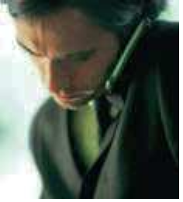Hi Jessica, it’s Miguel here.

Hello, Miguel. How are you?

B Starting formal calls

Good morning. Yamada
Hanako’s office.

Hello. Could
Can

Who’s calling, please?

Speaking means ‘Yes, it’s me.’ You can’t say ‘It’s me’ or ‘That’s me’ when someone asks for you on the phone.

I speak to Ms Hanako,
Note
please?

My name’s John Wang. I’m calling from JW Consultants in Hong Kong.

I’ll put you through.
One moment, please.

Ms is used instead of Miss or Mrs for a woman when you don’t know if she is married. Mr is used for all men.
Note
Thank you.

Good morning, Ms
Hanako. My name’s …

Yamada Hanako
(speaking).

C Ending calls

phone
I’ll
call you again next week.

Good
Nice to talk to you.

I think we’ve covered everything.
Note

on Thursday.

Thanks
Thank you

for calling. phoning.
See you
at the meeting.
in Bangkok.

Cover something means ‘talk about something’. I’ve/We’ve covered everything means ‘I’ve/We’ve talked about

Bye.
Goodbye.
everything that I/we needed to talk about.’

45.1

Look at A opposite. Put the conversation in the correct order.
1 2 3 4 5
a d
Speaking.

b Is that Nouriel?

c Hi Nouriel, it’s Maynard here.
Hi Maynard. How are you?

e Hello.

45.2

Look at B opposite. Complete the conversation.

(1) . Anya Petrovska’s office.

(2) .

Ms Petrovska, (3) ?

Who’s (4) ,
?

(5)
Morgan Delgado.

I’ll (6)
. One moment, please.

Thank you.

45.3

Complete the conversation with expressions from C opposite.

Right, so we’ve covered everything, I think.

So, you’ll be in touch next week to fix the exact details?

Yes, that’s it. (1)
in Warsaw.

Yes, I’ll (2)

It was very nice talking to you.
.

Yes, (3)

Goodbye.
too. Thanks (4) .

(5) .

When you answer the phone at work, what do you say?
Write the beginning of a phone conversation at work: a) with someone you know, and b) with someone you don’t know. Write two short dialogues.

46 Telephoning 2: spelling and numbers

A Telephone alphabet
When spelling a word on the phone, it can be difficult to hear the difference between these letters: B and P B and V D and T F and S I and Y M and N
Make sure you learn the English names for these letters:
A and R E and I O and U I and Y C and S G and J K and Q V and W
This list shows you:
how to say the names of the letters. the telephone alphabet.
If you want to spell a word, you can say A for Alpha, B for Bravo, etc.

A /eɪ/ Alpha | H /eɪtʃ/ Hotel | O /əʊ/ Oscar V /viː/ Victor
B /biː/ Bravo | I /aɪ/ India | P /piː/ Papa | W /ˈdʌbljuː/ Whiskey
C /siː/ Charlie | J /dʒeɪ/ Juliet | Q /kjuː/ Quebec | X /eks/ X-ray
D /diː/ Delta | K /keɪ/ Kilo | R /ɑː/ Romeo | Y /waɪ/ Yankee
E /iː/ Echo | L /el/ Lima | S /es/ Sierra | Z BrE: /zed/
F /ef/ Foxtrot | M /em/ Mike | T /tiː/ Tango | AmE: /ziː/ Zulu
G /dʒiː/ Golf | N /en/ November | U /juː/ Uniform

B Spelling

Who’s calling, please?

My name’s Anil Singh.

Can you spell your surname, please?

Is that one L or two?
Yes, it’s Singh: S for Sierra, I for India,
N for November, G for Golf, H for Hotel. I’m calling from Dillon Gupta, in Mumbai.

Two. D for Delta, I–double L
–O–N; new word, Gupta.

Sorry, but how do you spell Gupta?

C Numbers

G–U–P–T–A.
When you say telephone numbers, your voice goes up for each group – except for the last group, when your voice goes down.

00  Double oh (BrE) | 44  double four | 20  two oh | 9422  nine four double two | 5483  five four eight three
00  Zero zero (AmE) | 1 one | 212  two one two | 131  one three one | 6544  six five four four

46.1

46.2

Look at A opposite. You are talking on the phone about these numbers and letters. Correct the other person.
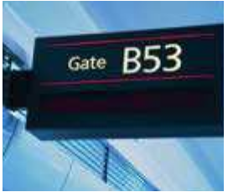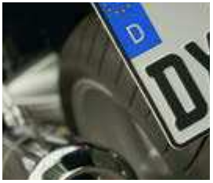1 Is that V for Victor? 3 Is that T for Tango?
No, B for Bravo.

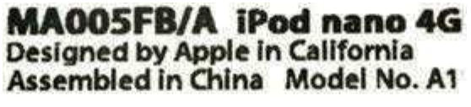2 Is that N for November? 4 Is that F for Foxtrot? Look at this telephone list for a company’s staff around the world.
a Spell the names. Use the telephone alphabet in A opposite.
b Use arrows as in C opposite to show how your voice goes up and down when saying the telephone numbers.

1 Mr Caire 00 33 1 9422 5122
C for Charlie, A for Alpha, I for India, R for Romeo, E for Echo.

2 Professor Fanshaw 00 44 131 946 9821

3 Ms Petersson 00 46 8 487 5044

4 Mr Hanks 00 1 918 324 6622

5 Doctor Tanawa 00 81 42 975 2349

6 Ms Dos Santos 00 55 61 648 7785

46.3

Look at B opposite. Match the expressions with the answers.
1 Who’s calling, please?
2 Can you spell that, please?
3 Which company are you phoning from?
4 Is that C–O–L–I–N–S?
a No, C–O–double L–I–N–S.
b John Collins and Associates.
c T for Tango, A for Alpha, N for November, Y for Yankee, A for Alpha; new word, H for Hotel, U for Uniform, double L for Lima.
d Tanya Hull.

Spell your name, your home address and your company address. Use the telephone alphabet.
What are your phone numbers – at home, at work and on your mobile? Remember to say them with the correct intonation.

47 Telephoning 3: checking information

A Showing understanding

I’m phoning from
AIE in Dubai.

Could you ask Lia to email the details?

It’s very important.

Right.

OK. I’ll do that.

I understand.

B Checking and confirming information

My name’s Gatarra. Sorry, I can’t hear you.
Could you speak up, please?

I’m sorry. My – name – is – Gatarra. One T and two Rs. G–A–T–A–double R–A. The company is Roehampton.

The number is 6975 0012.

Yes, of course. The number is 69–75–double 0–12.

Sorry, I didn’t get that. Could you speak more slowly, please?

That’s it. right.
So, that’s 6975 0012.

I’m calling from Leopardo in Bogotá.

Yes, it’s Leopardo.

Can
Could you

repeat the company name, please?
say that again, please?

John Gatarra
john.gatarra@roehampton.org.sg

My email address is John dot Gatarra
at roehampton dot org /ɔːg/ dot s g.

47.1

47.2

47.3

Look at A and B opposite. What do you say in the following situations?
1 You understand what the caller is saying. (3 expressions)
2 The other person is speaking too fast.
3 You can’t hear the other person.
4 You’re not sure how to write a name.
5 You want someone to say the word again.
6 You confirm some information. (2 expressions)

Complete the conversation with expressions from B opposite.
A: My name’s Carras.
B: Sorry, I didn’t get that. Could you (1) more slowly, please?
A: Yes, of (2) . My – name – is – Carras.
B: Is (3) one R or two?
A: (4) . C–A–double R–A–S.
B: What’s your email (5) ?
A: Spiros dot Carras at Athina dot G–R.
B: Sorry, I can’t hear you. Could you speak (6) , please?
A: I’m (7) . Here it is again. Spiros dot Carras at Athina dot G–R.
B: Spiros dot Carras at Athina dot G–R.
A: That’s (8) . Thank you very much.
B: No problem. Goodbye.

Look at B opposite. Write the conversation
Taro: 1 (Give your number.) Wang: 2 (Say you can’t hear.) Taro: 3 (Repeat your number.) Wang: 4 (Confirm the number.)

Write a short conversation in which you ask someone for their email address. Check the information.

48 Telephoning 4: messages

A When you receive a call

I’m afraid sorry,
he’s she’s
on another call.
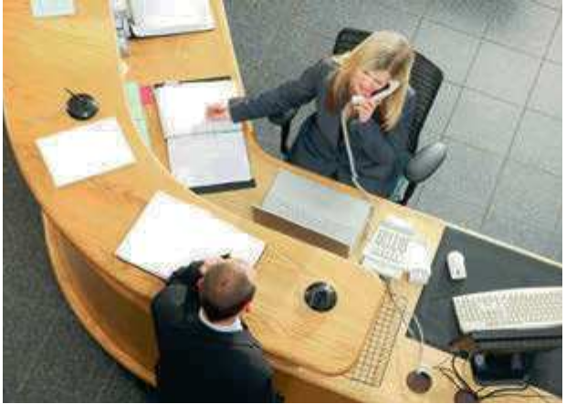not here at the moment.

Can I take a message? Who’s calling, please?
Which company are you calling from?

B When you make a call

Can
Could I leave a message?

Can
Could you ask
him
her to
call
phone me back
tomorrow?
as soon as possible?

C Leaving a message

Jose Oliveira’s office.

I’m sorry, he’s in a meeting. Can I take a message?

Can I have your number?

00 49 89 …

97 45 21. So, that’s
00 49 89 97 45 21.

Of course, I’ll give him the message.

Goodbye.

Hello. Can I speak to
Mr Oliveira, please?

Yes, please. My name’s
Angela Braun.

I’m phoning from Germany.
So it’s 00 49 89 97 45 21.

… 97 45 21

That’s right. Could you ask him to call me back? It’s very urgent.

Thank you very much. Goodbye.

48.1

Look at A and B opposite. Then put this conversation into the correct order. Look at the example brfore you begin.

1 d | 4 | 7 | 10 | 13
2 | 5 | 8 | 11
3 | 6 | 9 | 12
Receptionist Caller
a
So, that’s 00 1 212 233 5644.

b Can I have your number?

c Goodbye.

d Melissa Demirel’s office.

e I’ll give her the message, Ms Boyd.

f I’m sorry, she’s not here at the moment. Who’s calling, please?

h Hello. Can I speak to
Ms Demirel, please?

i Thank you very much. Goodbye.

j That’s it. It’s very urgent.

k My name’s Gaynor Boyd.
Can I leave a message?

l Can you ask Ms Demirel to call me back tomorrow morning?

g m
Yes, of course.

I’m phoning from New York. It’s 00 1 212 233 5644.

48.2

Use the information from the call in 48.1 above to complete this message form.

TELEPHONE MESSAGE

Message for:

Name of caller:

Will call again Please call

Phone number:

Urgent Not urgent

Think of the last phone message that you left. What did you say? Practise saying the message in English.

49 Telephoning 5: the wrong number

A Wrong number
Caller Person who answers

Can I speak to Terry
Connolly, please?

973 5589. I’m sorry. Bye.

B Wrong department

(I think) you’ve got the wrong number. What number did you want?

This is / My number’s 973 5598.

That’s alright.

Goodbye.

I’m phoning about a television that I bought on your website. It’s stopped working, but it’s still under guarantee.

OK.

Thank you.

C Wrong person

You’ve come through to the wrong department. This is the sales department. You want after-sales service.

I’ll try to put you through.

After-sales department.
How can I help you?
Caller Receptionist Person who answers

Hello. Can I speak to Serena Jones in the advertising department, please?

I’ll put you through.

Hello.

Is that Serena Jones?

Thank you.

No, this is Sarah Jones. You’ve got the wrong extension. I’ll try to put you through to the right one.

Sarah Jones tries to put the caller through to the right extension, but the line goes dead. The caller is cut off. So, he phones again and, this time, he gets through to Serena Jones.

49.1

49.2

49.3
Look at A opposite. Correct five mistakes in this conversation. A: 1 Can I speak through Terry Connolly, please?
B: 2 You’ve get the wrong number. What number do you want? A: 4955 2381.
B: 3 This was 4955 2318. A: 4 I’m excused.
B: 5 That’s correct.

Look at B opposite. You make four calls from your company. Write two lines of dialogue for each of the situations (1–4). Look at the example before you begin.

 | Organization that you call and the reason for your call | 1st department | 2nd department
1 | bank – cheque that hasn’t been paid | personal banking | business banking
2 | newspaper – advertisement that you want to put in the paper | finance department | advertising department
3 | computer company – order that you want to make | research and development department | sales department
4 | tax office – tax that your company has forgotten to pay | personal taxes department | corporate taxes department
1 A: I’m phoning about a cheque that hasn’t been paid.
B: You’ve come through to the wrong department. This is the personal banking
department. You want business banking.
2 A: B:
3 A: B:
4 A: B:

Look at C opposite. The caller gets through to Serena Jones and explains what happened to her. Complete the dialogue using the correct form of the verbs in brackets.
Caller: I (1) (phone) just now, but the receptionist
(2) (put) me through to the wrong Ms Jones. Serena Jones: Who did she (3) (put) you through to?
Caller: Sarah Jones in advertising.
Serena Jones: Oh, Sarah, she’s a friend of mine. Was she helpful?
Caller: Yes, she (4) (try) to (5) (put) me through to you, but we (6) (cut) off. The line
(7) (go) dead. So I (8) (call) again and this time I (9) (get) through to you.

Think of the last time that it was difficult for you to get through to someone on the phone. What happened?

50 Business writing: introduction

A Ways of communicating

I’ll send it to you by email.

I’ll email it to you.
send | something | to | someone  Nicola  Trent Media | by | fax post/mail email  courier (for example  FedEx or DHL)

email post/mail fax | something | to | someone Wang Ruby

email fax text
write send | an email  a text (message) / an SMS –  a mobile phone message  a fax  a letter | to | someone Akio Claudia
receive/get read  reply to |  | from

someone Alexander Rachel
I received the fax yesterday. I get over 50 emails a day.
Please reply to this message as soon as possible.

I texted Alexander to say that I was on my way to see him.

B Formal and informal
If you know someone well, you use an informal style. If you don’t know the person or the communication is very serious or official, you use a formal style. You need to think about the level of formality when you begin writing.

C | Beginning emails and texts
 | Writing an email to one person
 | More formal  Dear Mr Quinn | Dear Jim | Hello Jim | Less formal  Hi Jim
 | Dear Ms Dee, Dear Mrs Dee | Dear Ann | Hello Ann | Hi Ann
If you know someone very well, you can just use Hello and Hi without the person’s name, or
you can use just the person’s name without Hello or Hi.
Writing an email to several people
More formal Less formal
Dear all Hello, everyone Hi, everyone
Writing to an email address without a person’s name
When writing to an address such as ‘info@adventuretravel.co.uk’ or
‘humanresources@havajet.com’ you can write:
More formal Less formal
Dear Sir or Madam Hello
Or, you can just start the email with no expression at the beginning.
Texts are informal. You usually just start with no expression at the beginning, or just Hi and/or the person’s name.
See Unit 47 for how to say email addresses.

50.1

50.2

50.3

Look at A opposite. Choose the correct form of the right verb to complete these sentences.
1 I’ve (write / send) five faxes this morning, but I haven’t sent them yet.
2 I (reply / receive) her letter yesterday.
3 There’s no need to (read / reply) to this email.
4 I (get / post) this email from Rebecca.
5 I’ve (write / read) your text, but I haven’t (reply / send)
to it yet.
6 I’ll (fax / reply) the information to her.
7 He (text / receive) me to say he was on the train.

Look at B opposite. Kay Lumsden receives these emails and texts. Are they formal or informal? Look at the example before you begin.
1 A journalist who has never met Kay writes to ask her for an interview. formal
2 A colleague texts Kay to ask if she’s free for lunch.
3 A supplier that Kay doesn’t know writes to ask her for a meeting.
4 A friend emails Kay and asks if she’s free for a game of tennis.
5 Someone that Kay doesn’t know writes her an email to ask for a job.
6 A customer who has spoken to Kay once on the phone sends her an email asking for information about a product.

Look at B and C opposite. Write the beginning of each message in 50.2 above. If there is no beginning, just write ‘–’. Look at the example before you begin.
1 Dear Ms Lumsden
2
3
4
5
6

Write an email to a colleague in another department, asking for information about your company’s products or services. Use contractions and abbreviations where appropriate.

51 Business writing: emails 1

A Starting the message

Thank you (very much) (Many) thanks | for | your email. your message.  your invitation to …
inviting me to …
offering to …

I’m writing
This (email) is to

B Attachments
confirm the details of my trip. let you know about our plans.
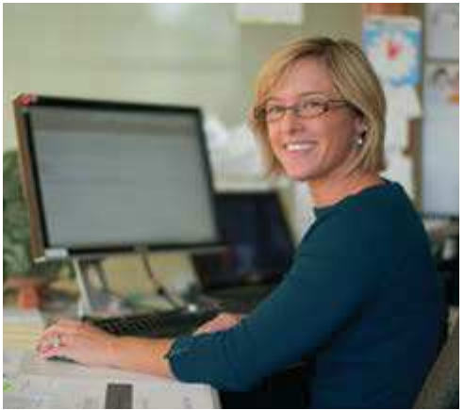let you have my latest ideas about the project.
An attachment is something that you send with an email. You can write:

Here is
Please find attached
I’m attaching
a file – information stored electronically.
a document: for example, a catalogue – a list of products and prices; a report – a document about a particular subject; or a spreadsheet with numbers.
a drawing, a photo or a map that I scanned – made a copy of words or pictures from paper onto a computer.

C Word combinations with ‘email’
Note
BrE: catalogue
AmE: catalog

copy someone in on forward
delete

D Requests

an email

send a copy at the same time to someone else
send an email that you have received to someone else remove an email from your computer

(Please) could you
Would it be possible to

call/phone me next week?
copy Ben in on all our emails?
forward this email to your colleagues?
let me know if you need anything else?
send me the document as soon as possible?

Please (don’t)
call/phone me next week.
delete the emails that I send you.
talk about our plans with your colleagues.

You can use please with all the requests. This can also go at the end of the sentence, for example: Could you copy Ben in on all our emails, please? Don’t put it in the middle of the sentence as this can sound rude: ‘Could you please copy Ben in on all our emails?’
Note

51.1

Look at A, B, C and D opposite. Complete this message.

rebecca.melesi@botswana-initiative.bw

kate.thomas@adventuretravel.co.uk

Arrangements for my trip

20 July
Dear Ms Melesi
(1) agreeing to see me next week. (2) (2 expressions) conﬁrm details of my trip: I’m ﬂying from London on Thursday afternoon, 26 July, and staying at the Intercontinental in the centre of Gaborone. (3)
send me a map showing where
your company is?
(4) attaching some information about my company, Adventure Travel. Please (5) if you need any more information about the company before the meeting.
And (6) copy my colleague Zoe
(7) all your emails? Many thanks. Yours sincerely
Kate Thomas

51.2
Look at B opposite. Match the situations (1–6) with the sentences (a–f). With an email, you want to send:
1 a drawing to help understand something
2 information about your company’s products
3 a drawing to show your company’s location
4 a document with detailed figures on costs
5 a document with information about a particular subject
6 copies of some letters received through the post
a I’ve scanned the correspondence and am attaching it.
b Please find attached a report.
c I’m attaching a scan of something
I drew quickly to show you what I
mean.
d I’m attaching a product catalogue.
e Please find attached a map.
f Here’s a spreadsheet.

51.3

Look at C and D opposite. Complete these sentences with one extra word where necessary or write ‘–’ if the sentence is already complete.
1 Could you call me next week?
2 Please could you copy my colleagues on any emails that you send?
3 Would it be possible to let me know if you need anything else?
4 I sent the wrong attachment just now. Please delete it.
5 Please forward the attached photos the sales team.

Write a message to an important client who is visiting your company next week, attaching a map to show where your company is. Remember to use formal language.

52 Business writing: emails 2

A Good and bad news

It was | (very) nice great  a pleasure | to meet you meeting you  to see you seeing you | in Seoul yesterday.  in Manila last week.

I’m | pleased delighted | to | let you know confirm | that | we agree to your plan.  we would like to go ahead with – start – the project.

Unfortunately, we
I’m sorry to say that we

B Ending emails
cannot agree to your proposals – suggestions – because …
are unable to continue our discussions.
have decided not to put money into this business idea.

Please don’t hesitate to get in touch if you need more information.
phone me if you would like to discuss things.

Looking forward to
hearing from you.
getting the information.
finalizing – finishing – the details.
doing business with you.

More formal Less formal
Best regards Regards Best wishes All the best Best
Yours sincerely Yours

BrE: Yours sincerely
Note
AmE: Sincerely
Note
Be careful with the use of capitals and small letters. Don’t write ‘Best Regards’, ‘yours sincerely’, etc.

C Email and text language
In emails and texts, many people use the following. They are a little informal.

abbreviations | doc – document; info – information; pls – please; v – very
contractions | I’ll – I will; she’s – she is; they’ve – they have
missing words | Pleased to hear – I am pleased to hear; Hope you got – I hope (that)  you got

In texts only, many people use the following. They are very informal.

abbreviations | evry – every; in tch – in touch; agn – again
letters for words | B – be; CU – See you; BTW – by the way; AFAIK – as far as I know
numbers used for words or in words | 2 – to, too; L8R – later

52.1

Complete the email with these expressions from A and B opposite.

Best cannot pleasure say sorry unable unfortunately

52.2
Dear Mr Takeshita
It was a (1) to meet you in Seoul last month to discuss the idea of working together with your company. We really liked your products. We have looked at the gures in more detail and we have decided that (2) it would be dif cult to sell your company’s products here in
South Korea. I am (3) to (4) that we (5) agree to your proposals and we are (6) to continue our discussions.
However, I hope we may be able to do business together in the future.
(7) regards
Rae Woo

Use correct forms of expressions from A and B opposite to complete this email.

Dear Rebecca
It was very (1) (2) (2 expressions) you in
Botswana last week. Thanks also for a great game of golf.
I have discussed your proposals with my colleagues, and (3)
(2 expressions) to say that we have decided to (4) and look at them in more detail.
We would like to discuss your ideas for holidays in Botswana for UK customers starting next year. I’m attaching a spreadsheet with some ﬁgures – possible prices, numbers of customers, etc.
Also attached is some information about Adventure Travel. Please (5)
to ask if you need any more information about the company.
Looking forward to (6) | from you and to (7) | business with you.
Yours sincerely
Kate Thomas
Sales director, Adventure Travel

52.3

Look at C opposite. Change these sentences from formal to informal. Look at the example before you begin.
1 I have posted the brochure to you. (contraction)
2 I enjoyed meeting you last week. (missing word)
I’ve posted
3 I am so glad you had a nice trip back to Jakarta. (contraction)
4 They are very interested in working with you. (contraction)
5 Please be very careful not to tell anyone. (2 abbreviations, a letter and a number)

52.4

Look at C opposite. Change these sentences from informal to formal.
1 Arrive in NY on Mon.
2 It was v good 2 speak to you yesterday.
3 I’ll be in tch agn soon.
4 CU L8R.
5 More info 2B sent L8R 2day.

Write an email with an attachment a) to send to a colleague, and b) to send to a customer. Use formal and informal language.

53 Business writing: letters
A Beginning letters
When you don’t know someone’s name When you know someone’s name
Formal Informal
Dear Mr Quiroga | Dear Antonio
Dear Ms Rias  Dear Mrs Rias | Dear Linda

Dear Sir/Madam
Dear Sir or Madam

B Letter layout

Adventure Travel Ltd
1190 Kensington High Street, London W8 7XZ Tel. +44 (0)20 7355 9300, Fax +44 (0)20 7355 9350
Web: www.adventuretravel.co.uk Email: info@adventuretravel.co.uk

Ms Rebecca Melesi
Botswana Initiatives Pty.
973 Main Mall Gaborone Botswana

17 September 2010

Dear Rebecca
Our agreement
It was very nice seeing you in London. Thank you for flying over so that we could discuss the details of our agreement on travel by our clients to Botswana. I think we covered1 all the points that we needed to talk about in order to reach a deal2. I have asked our lawyers to draw up3 a contract for an agreement between our two companies. (Sorry that there was no time for a game of golf!)
Please find enclosed two copies of the contract. Please could you sign one copy and send it back to me
by courier? Many thanks.
As agreed, the rst clients will be travelling to Botswana the year after next, so we must now work on the details of the tours that they will go on.
If this agreement is successful, we look forward to doing more business with you. Yours sincerely,

Kate Thomas
Sales director, Adventure Travel

1talked about
Note
2have an agreement
3write

You discuss something; you don’t ‘discuss about something’.

C | Ending letters
 | More formal  Yours sincerely | Less formal  Yours

BrE: Yours sincerely; AmE: Sincerely
When you begin with Dear Sir/Madam, use
Note
Yours faithfully (BrE only).

53.1

53.2

Read the letter in B opposite. Are these sentences true or false? Give reasons for your answer. Look at the example before you begin.
1 Kate does not know the name of the person that she is writing to.
false – She writes ‘Dear Rebecca’.
2 Kate and Rebecca still have to work on the details of the tours.

3 Kate asked lawyers to write the contract.

4 Kate asks Rebecca to send the contract back by post.

5 Kate hopes to work with Rebecca on other projects.

6 Kate met Rebecca in Botswana just before she wrote this letter.

7 Kate tells Rebecca for the first time that the customers will start going to Botswana the year after next.

8 Kate uses abbreviations and contractions in her letter.

9 Kate uses an ending that you can also use in formal emails.

Correct nine mistakes in this letter. There is one mistake in each line.

1 It was very nice meeting you here again in Montevideo. Thank you to fly over so
2 that we could pass a deal on your company buying meat from our farms in Uruguay.
3 My colleagues and I have draw up a contract for an agreement between our two
4 companies, as I think we have now discuss all the points that we needed to cover.

5 Please find enclosed two examples of the contract. Could you please sign one of
6 these and courrier it back to me by FedEx or DHL? Many thanks.

7 As agree, the first supplies of meat will be shipped from Uruguay next year, so we
8 must now work in the details of the arrangements for this.

9 If this agreement is succeeding, we look forward to doing more business with you.

Write a letter to someone in another company about a business deal between your two companies.

54 Presentations 1: getting started
A Preparation
Naomi Usk is an expert in presentation skills. She gives this advice for presentations:
Start to prepare – get ready – early. Think about your audience – the people
who will be at your presentation.
Write notes. Prepare slides, for example by using Microsoft PowerPoint.
Prepare handouts – pages with information for the audience.
Check the room – make sure the room is ready. Is there a microphone / a projector / a flipchart / a whiteboard? Is there an interactive whiteboard – a whiteboard connected to a computer, which the presenter controls using their finger or a special pen?

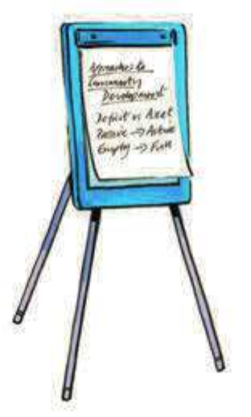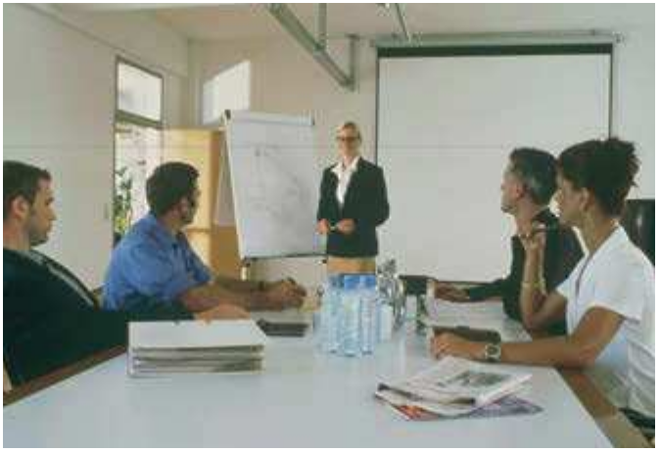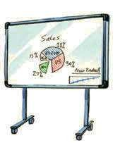
A microphone
A projector A flipchart A whiteboard

B Introduction
Introducing yourself and your subject

Good morning. My name’s … I work for Shell. I work in the research department.
Today I’m going to talk about …

Giving the plan

First, Then, After that, Next, Finally, | I’ll  I’d like to | talk about discuss look at  say something about move on to | sales.  our products.

Talking about questions

If you have any questions, please feel free to interrupt me – stop me while I’m talking.
I’ll be happy to answer them at the end.

54.1

54.2

54.3

Look at A opposite. Lisa Woo is the marketing manager at Ruby. She is going to give a presentation. What does she need in each case? Look at the example before you begin.
1 I want to be sure everyone can hear me. I need a microphone .
2 I want to write on paper so that everyone can see. I need a .
3 I want to know if there are enough chairs. I need to
.
4 I want to use my computer to show information. I need a .
5 The audience doesn’t need extra information on paper. I don’t need .

Look at B opposite. Complete the gaps in these sentences from a presentation.
1 Finally, I’ll say something the future – I’ll talk about possible new products for the next ten years.
2 First, I’ll look business-to-business products.
3 Hello. My name’s Yukio Watanabe. I work research and development at
Ruby, the electronics company.
4 Then, I’ll move consumer products.
5 Today I’m going to talk our latest business-to-business and consumer products.

Look at B opposite. Lisa Woo starts her presentation. Put what she says into the correct order.
1 2 3 4 5 6 7
a And to finish, I’ll say something about how we can work with your company.
b First, I’ll look at the technical side.
c I work for Ruby in the marketing department.
d If you have any questions, I’ll be happy to answer them at the end of my presentation.
e My name’s Lisa Woo.
f Then, I’ll move on to the sales possibilities.
g Today I’m going to talk about a new product that we have developed.

Write the introduction to a presentation and practise reading it aloud.

55 Presentations 2: the main part
A Starting the main part
Presentations are usually divided into sections – parts.

First (of all), Firstly, | let’s  I’d like to | look at | the products.  the sales figures.

B Moving between sections

enough on

the products.
That’s
all we have time for on
all I have to say about
the sales figures.

(So) | second, secondly, third, now, | let’s  I’d like to | move on to turn to | the next | point.
(And) | finally, |  |  | the last

C Slides and handouts

This slide/handout shows
Let’s (have a) look at
What I’m showing you here is
What you can see in this slide is

D Ending and questions
Ending

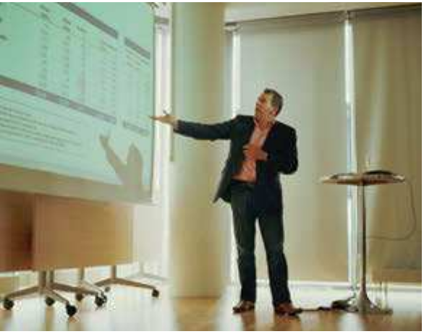last year’s sales. all our products.

That is the end of my presentation. Thank you very much.

Thank you for listening. coming.

Questions

Are there any questions?

I’m sorry, but I didn’t follow your question. Please could you repeat it?

I’m sorry, but I can’t give you that information.
Note
If you have any questions, I’ll be happy to answer them now.

I’m sorry, but I don’t know the answer to that. Can I check and get back to you?

The noun information is uncountable. You can talk about bits, items or pieces of information, but you can’t say ‘informations’.

55.1

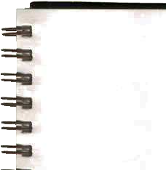Look at A, B and C opposite. Lisa Woo, Ruby’s marketing manager, is making a presentation about the Ruby 800 mobile phone. Write down what she says at the beginning of each section.

1 First, I’d like to talk about the technical side.
2
3
4
5
6

55.2

Look at D opposite. What do you say in these situations? Look at the example before you begin.
1 You don’t understand a question.
I’m sorry, but I didn’t follow your question.
2 You can’t answer a question because the information is confidential.

3 You are ready to answer questions.

4 You want someone to say the question again.

5 You don’t know the answer.

6 You want to find some information and then answer a question.

Write the beginning and the end of one of the main sections of the presentation that you started in Over to you in Unit 54.

56 Presentations 3: charts and graphs
A Pie charts
This pie chart shows where French people went abroad on holiday last year.

North and South America
8%
Rest of world
9%

Africa
17%

Europe
66%

This segment
The orange segment
The yellow segment
The segment shaded blue

B Graphs and bar charts

shows
that most people went to Europe on holiday – 66 per cent. the proportion of people who went to Africa – 17 per cent. the percentage of people who went to North and South
America – 8 per cent.

100

rise | stay the same | fall
go up | remain steady | go down
increase | level off | decrease

This line graph shows how figures/quantities/ 0
sales rose, stayed the same and fell. 0

100

This bar graph or bar chart shows sales of Ruby phones from January to June last year.
In January last year, Ruby sold 50,000 phones. In February, sales increased to
Thousands of units
175,000. Sales in March decreased from
175,000 to 100,000 units. In April, sales went up by 200,000 units to 300,000 units and in May they remained steady. Then in June, sales went up by 250,000 units to 550,000 units.
600

500

400

300

200

100

0

Jan

Feb Mar Apr May Jun
56.1

Look at A opposite. Complete and label the pie chart using the information below.

Hybrid (petrol plus battery) cars sold in the US last year
Model | Percentage
Prius | 60%
Camry | 15%
Civic | 11%
Highlander | 7.5%
Escape | 6.5%
Total | 100%

Now write a sentence about one of the segments.

56.2

Complete the table with verbs from B opposite. Look at Irregular verbs on page 142.

Infinitive Past simple
decreased
fell
went down
increased
rose
stayed the same
remained steady
levelled off

56.3

Look at B opposite. Complete the description of this bar graph.
In July last year, Ruby sold
400,000 phones. In August, sales
(1)
to 250,000. Sales in September
(2)
. In October, sales increased (3) 50,000 units to 300,000 units and in November they rose (4)
Thousands of units
300,000 (5) 350,000 units. Then in December, sales went (6) by 250,000 units

700

600

500

400

300

200

100

0

Jul

Aug Sept Oct Nov Dec
to 600,000 units.
Sales of Ruby mobile phones from July to
December last year

Describe the exports of a particular product from your country and the percentages exported to different places.

57 Presentations 4: comparing trends
A Graphs
This line graph shows world production of diamonds over the last fifteen years in Australia and Russia. Production is measured in carats. Fifteen years ago, Australia produced nearly 20 million carats, but production there has fallen steeply to less than 1 million carats this year. Production
in Russia rose steadily for the first nine years, from 9 million carats to 12 million. It has increased dramatically since then, to reach 23 million carats today.

26
24
22
Carats produced (millions)
20
18 Australia
16
14
12
10
8 Russia
6
4
2
0
15 years
ago
10 years
ago
5 years
ago
This
year

B ‘Less’, ‘more’ and ‘the same’
Production | is  has been was | (much) (slightly) | less more | in X | than | in Y.
 |  | (about) | the same |  | as

C Adjective and noun combinations

You don’t say ‘more that’, ‘less that’ or
Note
‘the same than’.

There was a  There has been a | fast steep dramatic rapid | rise. increase. fall. decrease.
 | slow gradual slight small

D Comparative adverbs

Adjective | Adverb | Comparative adverb
fast | fast | faster
slow | slowly | more slowly
gradual | gradually | more gradually

For comparative adjectives, see Unit 32.

57.1

Look at A opposite. Are these sentences true or false? Correct the false sentences.
1 The diagram is a bar chart.
2 It compares oil production in two countries.
3 Diamond production is measured in tons.
4 Diamond production in Australia was higher than in Russia 15 years ago, but today it is much lower.
5 Australian diamond production has fallen steadily and continuously for 15 years.

6 Russian production has risen fast over the whole period.

57.2

57.3

Look at B opposite. Correct the mistakes in these sentences.
1 Sales at General Motors last year were about the same than at Ford.
2 Sales at both companies were much least at the previous year’s.
3 Both companies made a loss, but GM’s loss was much bigger as Ford’s.
4 The loss at Ford was much more big as the previous year’s.
5 There are slightly more employees at GM that at Ford.

Look at C and D opposite. Then look at this information about Fabco. (We are at the end of year 3.) Are the sentences true or false?

 |  | Year 1 | Year 2 | Year 3
1 | Number of employees | 48 | 65 | 130
2 | Production | 3,011 units | 10,329 units | 10,666 units
3 | Sales | $497 million | $880 million | $912 million
4 | Profits | $89 million | $90 million | $122 million
5 | Taxes paid | $15 million | $22 million | $9 million

1 The number of employees rose dramatically this year – more dramatically than before.
2 Production rose rapidly this year in relation to last year.
3 Sales have gone up this year, but more slowly than in the previous year.
4 Profits increased faster this year than last year – in fact they only rose slightly between years
1 and 2.
5 There was a steep increase in taxes from year 1 to year 2, but a dramatic fall in year 3. (We changed our accountants!)

Find the profit figures for two companies for the past five years. Write six statements comparing them, using language from this unit.

58 Presentations 5: site tours
A Company sites
At Ruby’s main – most important – site you can find:
the reception area – where visitors arrive
the offices – where people work on managing, planning, etc. the factory or manufacturing plant – where products are made
the R&D (research and development) department – where people work on new ideas, products, etc.
the training department – where employees learn how to do their work

B Introduction to the tour
Guide: Good morning, ladies and gentlemen, and welcome to Ruby. Today, we’re going to see some of the departments on this site. We’ll start here in the reception area, then I’ll show you the main departments and finally we’ll look at the production area. I’m afraid we don’t allow photography during the tour.

C Guided tour
Guide: Let’s now leave the reception area and move on to the offices. Come this way, please.
Here on the left you can see the marketing department and on the right, the finance department. This is our finance director, Cara Long.
Cara Long: Hello, everyone.
Guide: Follow me and let’s go into the manufacturing plant. This is where we make our mobile phones. We make a million phones a year in this plant.
Right, let’s continue now to the research and development department. I’m afraid this area is restricted – closed to the public. But as you can see through the window, we’re testing new designs for our phones.
Now, finally, we can have a look at the training department. This is where we do
all the company training. In this room, you can see some of our managers from the finance department on a course in advanced finance. Can I ask you to keep your voices down – speak quietly – in this area?

58.1

Look at A opposite. Match the places (1–5) with what the guide says (a–e) during the guided tour of a company.
1 the factory
2 the offices
3 the training department
4 the reception area
5 the R&D department
a We work on new ideas for our products here.
b This is where people learn how to do their job.
c This is where we make the products.
d This is where our managers work.
e We welcome company visitors here.

58.2

Look at B and C opposite. You are the guide on a company site tour. What do you say in these situations?
1 Ask your visitors to speak more quietly.

2 Tell them to follow you into the finance department.

3 Say that they cannot take photos.

4 Tell them that some of the company’s machines are on the left.

5 Explain that they cannot go into room 101.

58.3

Look at B opposite and the plan below. Complete the site tour commentary.
We’ll start here in the reception area. Can I ask you to keep your voices (1) in this area? Let’s now leave the reception area and (2) on to the offices. Come this
(3) , please. Here on the (4) , you can see the sales department and on the (5) , the human resources department.
Let’s (6) now to the R&D department. This is where we design new computers. We can now have a (7) at the training department. This is where we do all the company training, including English classes for our employees.
I’m sorry, but we can’t go into the manufacturing plant. It’s (8) and closed to the public. Are there any questions?

SALES DEPARTMENT
R&D
DEPARTMENT
TRAINING
DEPARTMENT
MANUFACTURING
PLANT

RECEPTION AREA

HUMAN RESOURCES DEPARTMENT

Write the beginning of a guided tour of your site. Welcome the people to the company and name the places you are going to visit. Then write what you say when you take them to the first place.

59 Meetings 1: organizing a meeting

A Word combinations with ‘meeting’

arrange

organize a meeting
chair be in charge of a meeting
attend go to a meeting
a meeting
miss not go to a meeting
postpone change a meeting to a later time
cancel not have a planned meeting

B Agendas
Here is an agenda. An agenda is a list of items or points – different things – to talk about at a meeting. It begins with the date and the venue – the place where the meeting will be.
Before the meeting, someone sends out the agenda.
If you cannot attend a meeting, you send your apologies – a message to say that you cannot be there. At the beginning, someone reads out these messages.
The minutes of a meeting are written notes of what is said and decided in the meeting. During the meeting, someone takes the minutes –
writes down what is said and decided. After the meeting, someone sends out the minutes –
sends copies to everyone.
The last item on the agenda is usually AOB (any other business) – other things that people want to talk about.

C Types of meeting
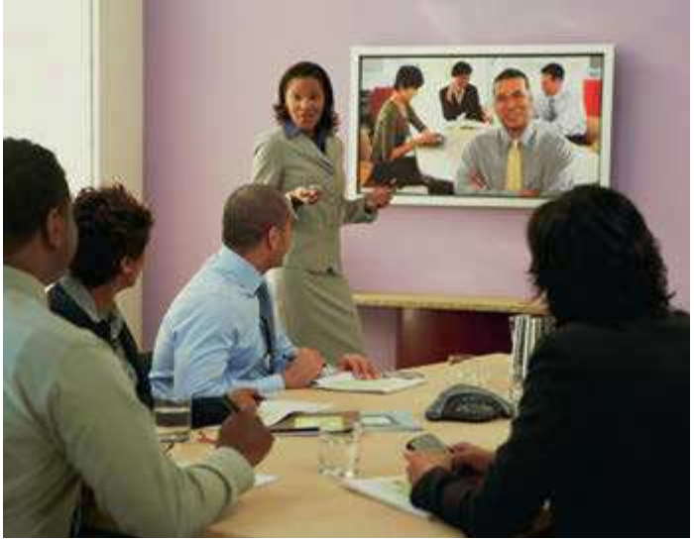Most meetings occur face-to-face, with the chair – the person in charge – and the participants all in the same room. But there are also virtual meetings, with participants in different locations – places – connected by video link in a system of videoconferencing.

AGENDA
Staff meeting, 25 January
Venue: Meeting room 3

Apologies for absence
Minutes of the last meeting
1 Car parking
2 Company restaurant
3 Holiday dates
4 AOB

59.1

59.2

Look at A opposite. Choose the correct verb to complete these sentences.
1 She (missed / arranged) the meeting because she was late for work.
2 I decided to (cancel / arrange) the meeting because there was nothing to talk about.
3 We can (postpone / cancel) the meeting until next week if necessary.
4 I asked Jean to (arrange / miss) the meeting next week, but there were no rooms available.
5 They (attended / postponed) the meeting, but they didn’t hear anything interesting.
6 This meeting is very important. Don’t (miss / attend) it!
Look at A and B opposite. Complete this memo with expressions from the box. agenda attend items minutes venue

MEMO

From: Chief Executive To: All managers
Please find enclosed the (1) for next week’s meeting. Please make a note of the (2) : we are meeting in room 7. Please let me know if you are unable to (3) .
Please find attached a copy of the (4) from the last meeting.
If you want me to add other (5) to the agenda, please let me know.

59.3
Look at A and B. Match these verbs and nouns. Then match the expressions with their meanings. attend send send out take

your apologies the minutes the agenda a meeting

59.4
1 make the formal record of a meeting
2 say that you will not be able to come to a meeting
3 go to a meeting
4 give people a list of things to talk about at a meeting

Complete this text with correct forms of expressions from C opposite. Use some expressions more than once.

In our company, top managers based in different (1) no longer fly to
(2) meetings with each other. Modern (3) systems give you the feeling that the other participants are in the same room with you. Of course, the chair can
be in any (4) too. Meetings using a (5)
mean that managers don’t have to spend hours on international flights, and these
(6) meetings are much cheaper and easier to organize.

Write the agenda for a meeting in your organization. Show the date, the venue and the items to talk about.

60 Meetings 2: chairing a meeting
A Chairing

The chairman, chairwoman or chair – the person in charge of the meeting – opens, runs –
manages – and closes the meeting.
Opening the meeting

Is everybody ready? Let’s make a start.

James and Chris send their apologies.

Does everyone agree with the minutes of the last meeting?

Running the meeting

So, the first item is the company car park.

Let’s move on to the next item: the company restaurant.

B Interruptions and how to stop them
Interrupting

Can | I Isabella | say something come in | here?

Stopping interruptions

Can I say something here about the cost of all this?

Just a moment.
I haven’t finished …
Can I just finish? Let him/her finish.

Just a moment. I haven’t
finished talking about the plans.

60.1

60.2

Look at A and B opposite. Some of these sentences are incorrect. Correct the sentences where necessary.
1 Let’s make to start.
2 Joanna sends her apologize.
3 Does everyone agree the minutes of the last meeting?
4 The first point is holiday dates.
5 Let’s move in to the next item.
6 Pia, can you to say something here?
7 Just a moment. Can I just finish what I was saying?
8 Just a moment. Let Roberto to finish.

You are chairing a meeting. What do you say in these situations?
1 You want Val to let Yvonne speak.

2 You want Val to let Yvonne finish.

3 You start the meeting.

4 You say that Tanya and Stefan are sorry that they cannot attend.

5 You ask if everyone agrees with the minutes of the last meeting.

6 You introduce the first item – the company’s new restaurant.

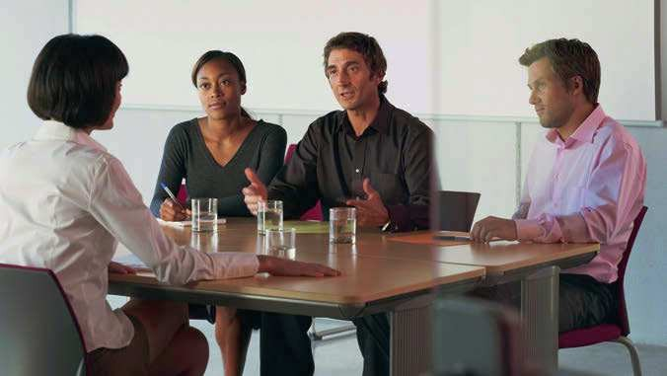

Think about a recent meeting you attended. Write down what the chair said to open, run and close the meeting. Use some of the expressions in this unit and in Unit 59.

61 Meetings 3: opinions and suggestions
A Opinions, agreeing and disagreeing
An opinion is what a person thinks about an idea or subject. If you have the same opinion as another person, you agree. If you have a different opinion, you disagree.
Asking for opinions Giving opinions

What do you think
What’s your opinion
about … ?
of … ?
I think …
In my opinion …

Agreeing Disagreeing

I agree. Exactly. That’s right.
I agree with Peter about that.

Nadia: What’s your opinion of the service in the company restaurant?
Olivier: In my opinion, it’s very bad! Pierre: I agree. It’s so slow.
Quentin: I’m afraid I disagree. I think it’s quite good.

You say I agree with … .
You don’t say ‘I am agree with …’.
Note
I don’t agree.
I’m afraid I disagree. Yes, but …

B Suggesting and explaining
If you make a suggestion, you tell people about an idea or plan for them to think about.
Making suggestions

How about … ?
What about … ?

Why don’t we … ?
I have an idea. Let’s …

Responding

That’s a good idea.

Asking for explanation

Sorry, I don’t understand. Do you mean that … ?
Are you saying that … ?

Nadia: I disagree with Quentin about this. We need to find new people to work in the restaurant.
Olivier: Can I come in here? I have an idea. Let’s use a company from outside.
Pierre: Sorry, I don’t understand. Do you mean that the people working in the restaurant should not be employees of our company?
Olivier: That’s right. The restaurant company can be completely independent. Reina: That’s a good idea.
Quentin: I’m afraid I disagree. We’ll lose control of the restaurant.

61.1

61.2

61.3

Look at A and B opposite. Complete this conversation by putting the phrases (a–g) in the correct places (1–7).
a I have another idea.
b I disagree with Ben c That’s a good idea! d Yes, but
e Do you mean
f That’s right.
g What do you think
Anna: So, who’s the best person for the job? (1) , Ben? Ben: Lea Smith is very good. She has a lot of experience.
Charlene: (2) about this. Malcolm Jones may be younger, but he has a lot of experience.
Ben: (3) Lea can start work next week. Malcolm can only start next month. Dan: Can I come in here? (4) We can give them both a job as a sort of test for
six months.
Ella: (5) keep them both for six months and then give one of them the permanent job?
Dan: (6)
Anna: (7) I hadn’t thought of that.

Look at A and B opposite. Colleagues at Newcorp are talking about a new supplier, Partco. Put these expressions in the order they are used at a meeting.
1 2 3 4 5 6 7
a I have an idea. Let’s tell them we will order more products if they can make the delivery more reliable.
b I think Partco’s products are very cheap.
c What do you think about Partco, Manuel?
d Is everybody ready?
e Yes, but they never deliver on time.
f That’s a good idea.
g Can I say something here? I agree with Linda – deliveries from Partco are always late.

Match the different parts of the meeting (1–7) with the expressions (a–g) in 61.2 above.
1 Naomi interrupts and agrees with Linda.
2 Manuel gives his opinion.
3 Manuel makes a suggestion.
4 Linda disagrees with Manuel.
5 The chair, Chris, starts the meeting.
6 The chair asks for Manuel’s opinion.
7 Chris responds.

Think again about a recent meeting you attended. Write six lines of what people said to agree and disagree. Use some of the expressions in this unit.

62 Meetings 4: agreeing action and closing
A Action points
The person who takes the minutes also writes down action points – things that individual participants must do before the next meeting.
Minutes

Date: 1 March Venue: Meeting room 3
Chair: Monica Present: Nadia, Olivier, Pierre, Quentin

Apologies and minutes Ralph and Susan sent their apologies. N read the minutes of the last meeting and everyone agreed that they were accurate1. O agreed to take the minutes for this meeting.

1 Car parking
There was a lot of discussion2 about building a bigger car park. N, O
and P were for this, but M and Q were against.
It was decided to ask employees if they will support ideas to reduce car use, like leaving their car at home one day a week. There was a difference of opinion3 between N and Q about this.

2 Staff restaurant
Q said that we must nd exact costs of the restaurant today, compared to costs of possible outside suppliers. Q to research4 the costs and report back5 by email before the next meeting. We decided to set a target6 of a
10 per cent reduction in costs for the company.

3 Staff holidays
We discussed what happened last year when too many people were away in August and customers complained. We decided that staff must take two weeks in winter and two weeks in summer. We voted on7 this and the vote was unanimous8.
Action by

Nadia 15 Mar

Quentin 10 Mar

– –

1correct
2talking
3they disagreed
4find out about
5tell everyone about the results
6decide an objective
7said formally if we were for or against
8everyone voted the same way

B Closing
The chairman, chairwoman or chair closes the meeting. He/She sums up – repeats the main ideas
– and recaps the action points – goes over them again. He/She might also ask individual participants to follow up their individual action points – do what they said they would do.

We must stop there.
To recap the action points, Nadia is going to …

Can I sum up? We decided …
Please follow up your individual action points.

I think that’s all for today. Thank you for coming. See you at the next meeting.
The next meeting is on …

62.1

62.2

Complete the table with expressions from A and B opposite.

Verb or phrasal verb | Noun
 | discussion
 | follow-up
 | recap
 | report
 | research
 | vote

Use correct forms of the expressions in the box to replace the underlined expressions.

disagree with follow up recap report back research vote on

62.3
1 Can we just go over again who is going to do what?
2 Nadia didn’t have the same opinion as Monica.
3 Olivier, can you get the information on this subject and tell us all about it at the next meeting.
4 OK. Let’s show what we each think about this. Those for, raise your hands.
5 Please can you all do what you said you were going to do about the action points.

Look at A and B opposite. Some of these statements are incorrect. Correct the statements where necessary.
1 If you can’t attend a meeting, you send your minutes.

2 If you have a difference of opinion with someone about something, you disagree about it.

3 If you offer to find out about something and talk about it at the next meeting, you offer to report backwards.

4 If you talk about something, you discuss about it.

5 If you vote on something and everyone else votes the same way, the vote is ambiguous.

6 If you are the chair and you go over the action points again, you research them.

7 If you ask people to do what they agreed to do, you ask them to follow up on their individual action points.

Write the action points for a meeting that you attended recently.

